**Prepare for interviews with Interview Warmup**

Now that you have developed new skills and knowledge in business intelligence, it’s time to start preparing for interviews. [Interview Warmup](http://grow.google/interview-warmup) is a tool that helps you practice answering questions to become more confident and comfortable throughout the interview process.

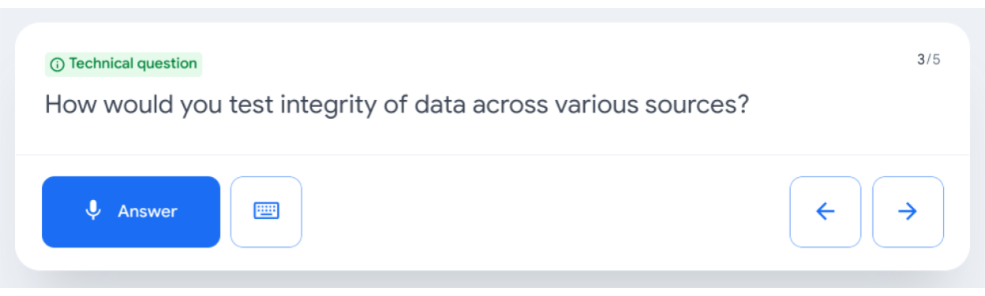

**Get started**

Follow these steps to start a five-question practice interview related to BI and data analytics:

1. Go to [grow.google/interview-warmup](http://grow.google/interview-warmup).
2. Click **Start practicing**.
3. Select **Data Analytics** to open an additional menu.
4. Select **Business Intelligence** as the field you wish to practice.
5. Click **Start**.

The interview will last about 10 minutes, and the questions will vary with each attempt. During each interview session, you will be asked two background questions, one behavioral question, and two technical questions. You are encouraged to try as many practice interviews as you want.

You can also review complete lists of [business intelligence interview questions](https://grow.google/certificates/interview-warmup/category/business-intelligence/all-questions/) or [general interview questions](https://grow.google/certificates/interview-warmup/category/general/all-questions/) if you'd like to focus on a particular topic.

**How it works**

Interview Warmup asks you interview questions to practice delivering your responses verbally. Your answers will be transcribed in real time, allowing you to review how you responded. In addition, Interview Warmup's machine learning algorithm can detect insights that can help you learn more about your answers and improve the way you communicate.

Here are a few examples of questions the tool might ask:

* How does a career in business intelligence line up with your longer term career goals over the next few years?
* How might your role as a business intelligence analyst impact an organization? What are some of the challenges of using business intelligence?
* How would you test integrity of data across various sources?
* What are some examples of data visualization deliverables? How would you use one of these deliverables?
* Tell me about some of the potential challenges of working with stakeholders. What would you do on a project to prevent or overcome these challenges?

Here are some of the insights that Interview Warmup provides:

* **Talking points:** The tool lets you know which topics you covered in your answer, such as your experience, skills, and goals. You’ll also be able to view other topics that you might want to consider covering.
* **Most-used words:** The tool highlights the words you used most often and suggests synonyms to broaden your word choices.
* **Job-related terms:** The tool highlights the words you used that are related to the role or industry in which you are preparing to work. You’ll also be able to view an entire list of job-related terms that you might want to consider including in your answer.

Interview Warmup gives you the space to practice and prepare for interviews on your own. Your responses will be viewable only by you, and they won’t be graded or judged.

**Key takeaways**

Practicing for interviews is an important skill for your career in business intelligence. Using Interview Warmup can help you practice interview questions and receive feedback in real time. As you practice, you will gain confidence and be able to prepare more polished responses for common interview questions.